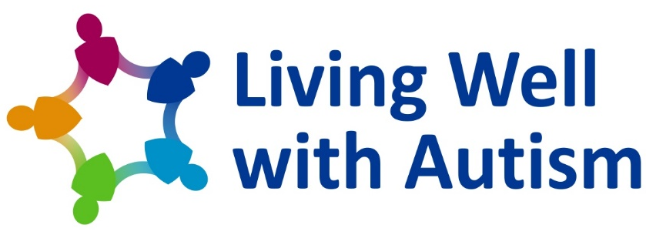  Support for people affected by Autism Spectrum Condition  Funded by Derbyshire County Council  Delivered by Relate Derby and Southern Derbyshire | Please post the completed form to:
Living Well with Autism
3 Wentworth House
Vernon Gate
Derby DE1 1UR

Or email it to:
info@livingwellwithautism.org.uk

 | If you have any questions please call us on 01332 301350 or send us an email
Initial request for support | For office use:

Support wanted  (please tick all that apply): |  |  | 1 Day  Education Course |  |  | Counselling |  | Coaching |  |  | Not sure
Please tell us who wants support
Name
Date of birth |  |  |  | Gender identity
Home address

Which GP surgery are they registered at?
NHS number (if known)
Eligibility
Does this person have a diagnosis of Autism Spectrum Condition (ASC)? |  |  |  |  |  |  |  |  | Yes |  |  |  | No
Does this person have characteristics of ASC, but not have a formal diagnosis? |  |  |  |  |  |  |  |  | Yes |  |  |  | No
Is this person a family member or a carer of an adult affected by ASC? |  |  |  |  |  |  |  |  | Yes |  |  |  | No
Who should we contact to discuss support options?
Main contact name and number
Second contact name and number
Email address
If you are requesting support for someone else please give your details
Your name
Your contact numbers
Your relationship to the person
If you are requesting support because you are from another agency, please give us some more details
Your role
Who you work for
Your email address
Your postal address
Where did you hear about
Living Well with Autism?
Thank you for taking the time to fill in this form

